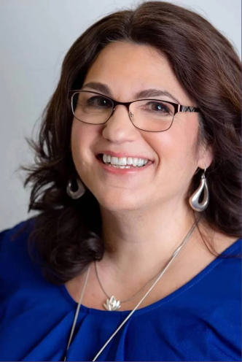
Psychic Lydia Dustin
BIO:

Lydia Dustin is known for being Boston’s premier lipstick reader, and for her ability to perceive the energy of people (living & in spirit), places, and things.

She is like a real-life Harry Potter; a wizard raised by Muggles. Lydia was adopted as a baby by two skeptical college English professors and raised in a strict traditional Irish Catholic family. Unbeknownst to her adopted parents Her biological family were psychics, witches, and folk healers, their gifts and traditions going back generations in the mystical islands of Santa Maria and San Miguel in the Azores.

Later in life Lydia opened to her gifts while training to be a healer at the Rhys Thomas institute of Energy Medicine. She went on to hone her psychic abilities and study Reiki with her mentor Lisa Campion. Now as a Master Reiki and Energy Healer, Lydia’s brings two worlds together into a unique psychic healing experience that is powerfully mystical, yet comfortable – and always entertaining. Lydia reads Tarot cards, pictures, objects, spaces, and the energy of anyone alive or in spirit.

Contact:
Lydia Dustin Kirchthurn
Franklin MA 02038
+1 857-928-4824
Lydiadustin@gmail.com
www.lydiadustin.com

Psychic Performer
d/b/a Lydia Dustin
Talent for:
Harrington Events

Media
Articles:
- Glamour.com: I Got My Lips Read By a Psychic Here’s What I Learned

https://www.glamour.com/story/lip-print-reading-i-got-my-lips-read-by-a-psychic-heres-what-i-learned

Radio/Podcast interviews:
- KCAA Radio: Guys Guy Radio with Robert Manni

https://irepod.com/podcast/guy-s-guy-radio-with-robert-manni/-525-coach-author-gary-waters-and-psychic-face-rea

- Empower Radio: The Miracle of Healing with Lisa Campion

https://www.empoweradio.com/home/m/podcasts/on-demand/miracle-of-healing/817463-Energy-Healing-For-Empaths-featuring-Lydia-Dustin.html
​
https://www.empoweradio.com/home/podcasts/on-demand/miracle-of-healing/817493-The-Art-Psychic-Reiki-featuring-Lydia-Dustin.html

Talk Show Interviews:
- Late Night New England:
https://youtu.be/qxb82AO89L8

Events:
- Encore Boston Harbor 2023 VIP New Years’ Eve Party, Boston
- Grimoire Academy Cast member 2022 season
- 2022 Dreamland Foundation at Nantucket, Dreambelievers Celebration
- Encore Boston Harbor 2022 VIP New Years’ Eve Party, Boston
- Hub50House Grand Opening, Boston

Social Media:
Instagram: https://www.instagram.com/LydiaxDustin [2k followers]
Facebook: https://www.facebook.com/Lydiadustin [1.5k+ followers]
and https://www.facebook.com/lydiaohlydia [2.5K followers]
Blog: https://lydiadustin.blogspot.com [100K hits]

